Date created: 5 May 2021

4K-Soft Ltd.

The project consists of 3 parts:

1) MySQL database

2) Php backend application created using Yii2 framework and provides API for mobile application

3) Native iOS mobile application

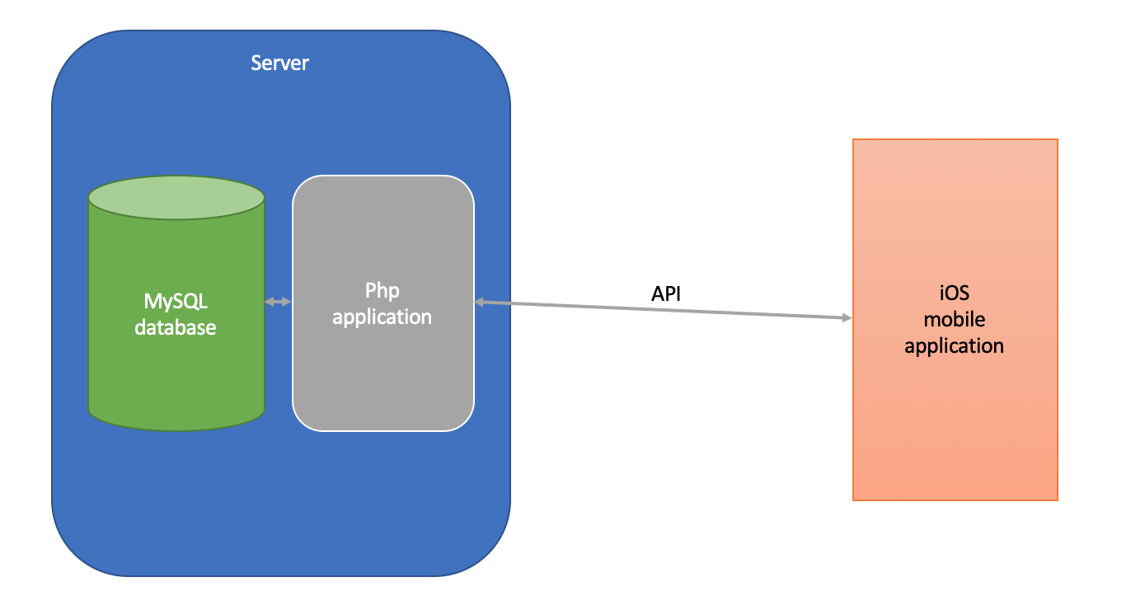

Currently backend application deployed on server with such configuration:

1) Debian GNU/Linux 10

2) PHP 7.3.8 (cli)

3) MySQL 8.0

4) Apache 2.4.38

Backend application deploy instruction:

1. Clone project from repository: <https://git.4k.com.ua/yuriy.chernyavskyi/aidatingapi.git>

2. Execute “Composer install” command in project root folder

3. Create your database on server

4. Edit project file “config/db.php” with your data to connect database. Example below:

*return [*

*'class' => 'yii\db\Connection',*

*'dsn' => 'mysql:host=localhost;dbname=yii2basic',*

*'username' => 'root',*

*'password' => '1234',*

*'charset' => 'utf8',*

*];*

5. Execute “php yii migrate” command in project root folder to perform database migrations

6. Setup web server config file (host file) to access API from global network. Currently project deployed on test server and can be accessed via url: <http://aidatingapi.dev2.4k.com.ua/>

iOS application source codes: <https://git.4k.com.ua/kmi_4k/AIDating>

iOS application was never published, but delivered via TestFlight after each build